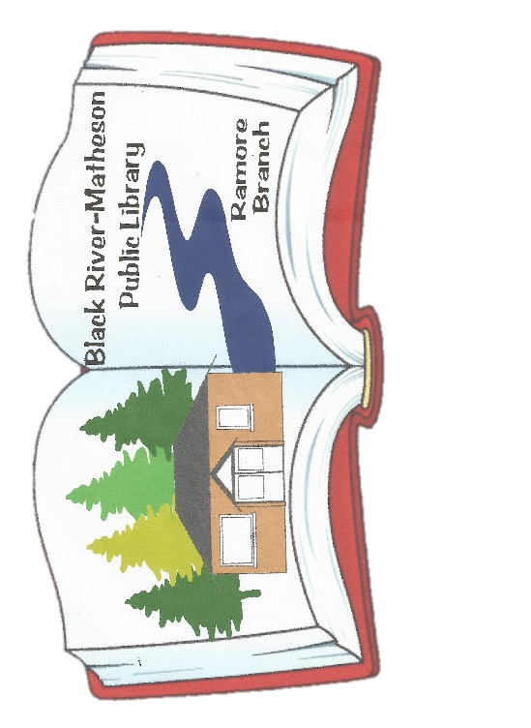
The libraries have over 16,000 titles in English & French!
Black River – Matheson Public Library
352 Second Street
Matheson, Ontario P0K1N0
Phone 705-273-1089
brmlibrary@gmail.com
http://blackrivermatheson.olsn.ca
Hours:
Monday 12-5pm
Tuesday-Thursday 12-7pm
Friday 12-5pm
Saturday & Sunday CLOSED

Ramore Branch
#112-375 McIntyre Avenue
Ramore, Ontario P0K 1R0
Phone: 705-236-1126
Hours:
Tuesday 3-6pm
Thursday 4-7pm

Both Locations are
Wheelchair Accessible

“A Place to Learn, Grow & Connect”

Mission Statement
The Black River – Matheson Public Library makes available, within a welcoming and secure environment, a range of print, electronic and human resources with which residents of a variety of ages and cultures, may enrich their lives through the pursuit of knowledge, skills, and leisure.



LIBRARY SERVICES
Things to do at The Library!
- iPads
- Puzzles
- Laminator
- Toys
- OSMO
- KANO
- scrapbooking
tools
Membership
There is no charge for residents of Black River – Matheson
$25 Non- Resident Fee Per Year

- Wii / Nintendo 2DS
- Legos
- Crafts
- STEM kits
- Audio Books
- Documentaries
- Happy Planner Punch




Borrowing Options
Books/Magazines/AudioBooks
DVD/BluRay Movies & Mini Series
Puzzles / Nordic Ski Poles
Knitting Needles / Loom

Genres We Have!
Fiction
Large Print Fiction
Non-Fiction
Biographies
Teen Section
Children Section
Local History Section
Magazines
Interlibrary Loans Available
For books you want but we don’t have!

Borrowing Limits
Books & Audio books 3 Weeks
Magazines 2 Weeks
DVD / Blu-Ray 1 Week
Renewals may be made in person, via phone or e-mail
Holds may be placed through our website



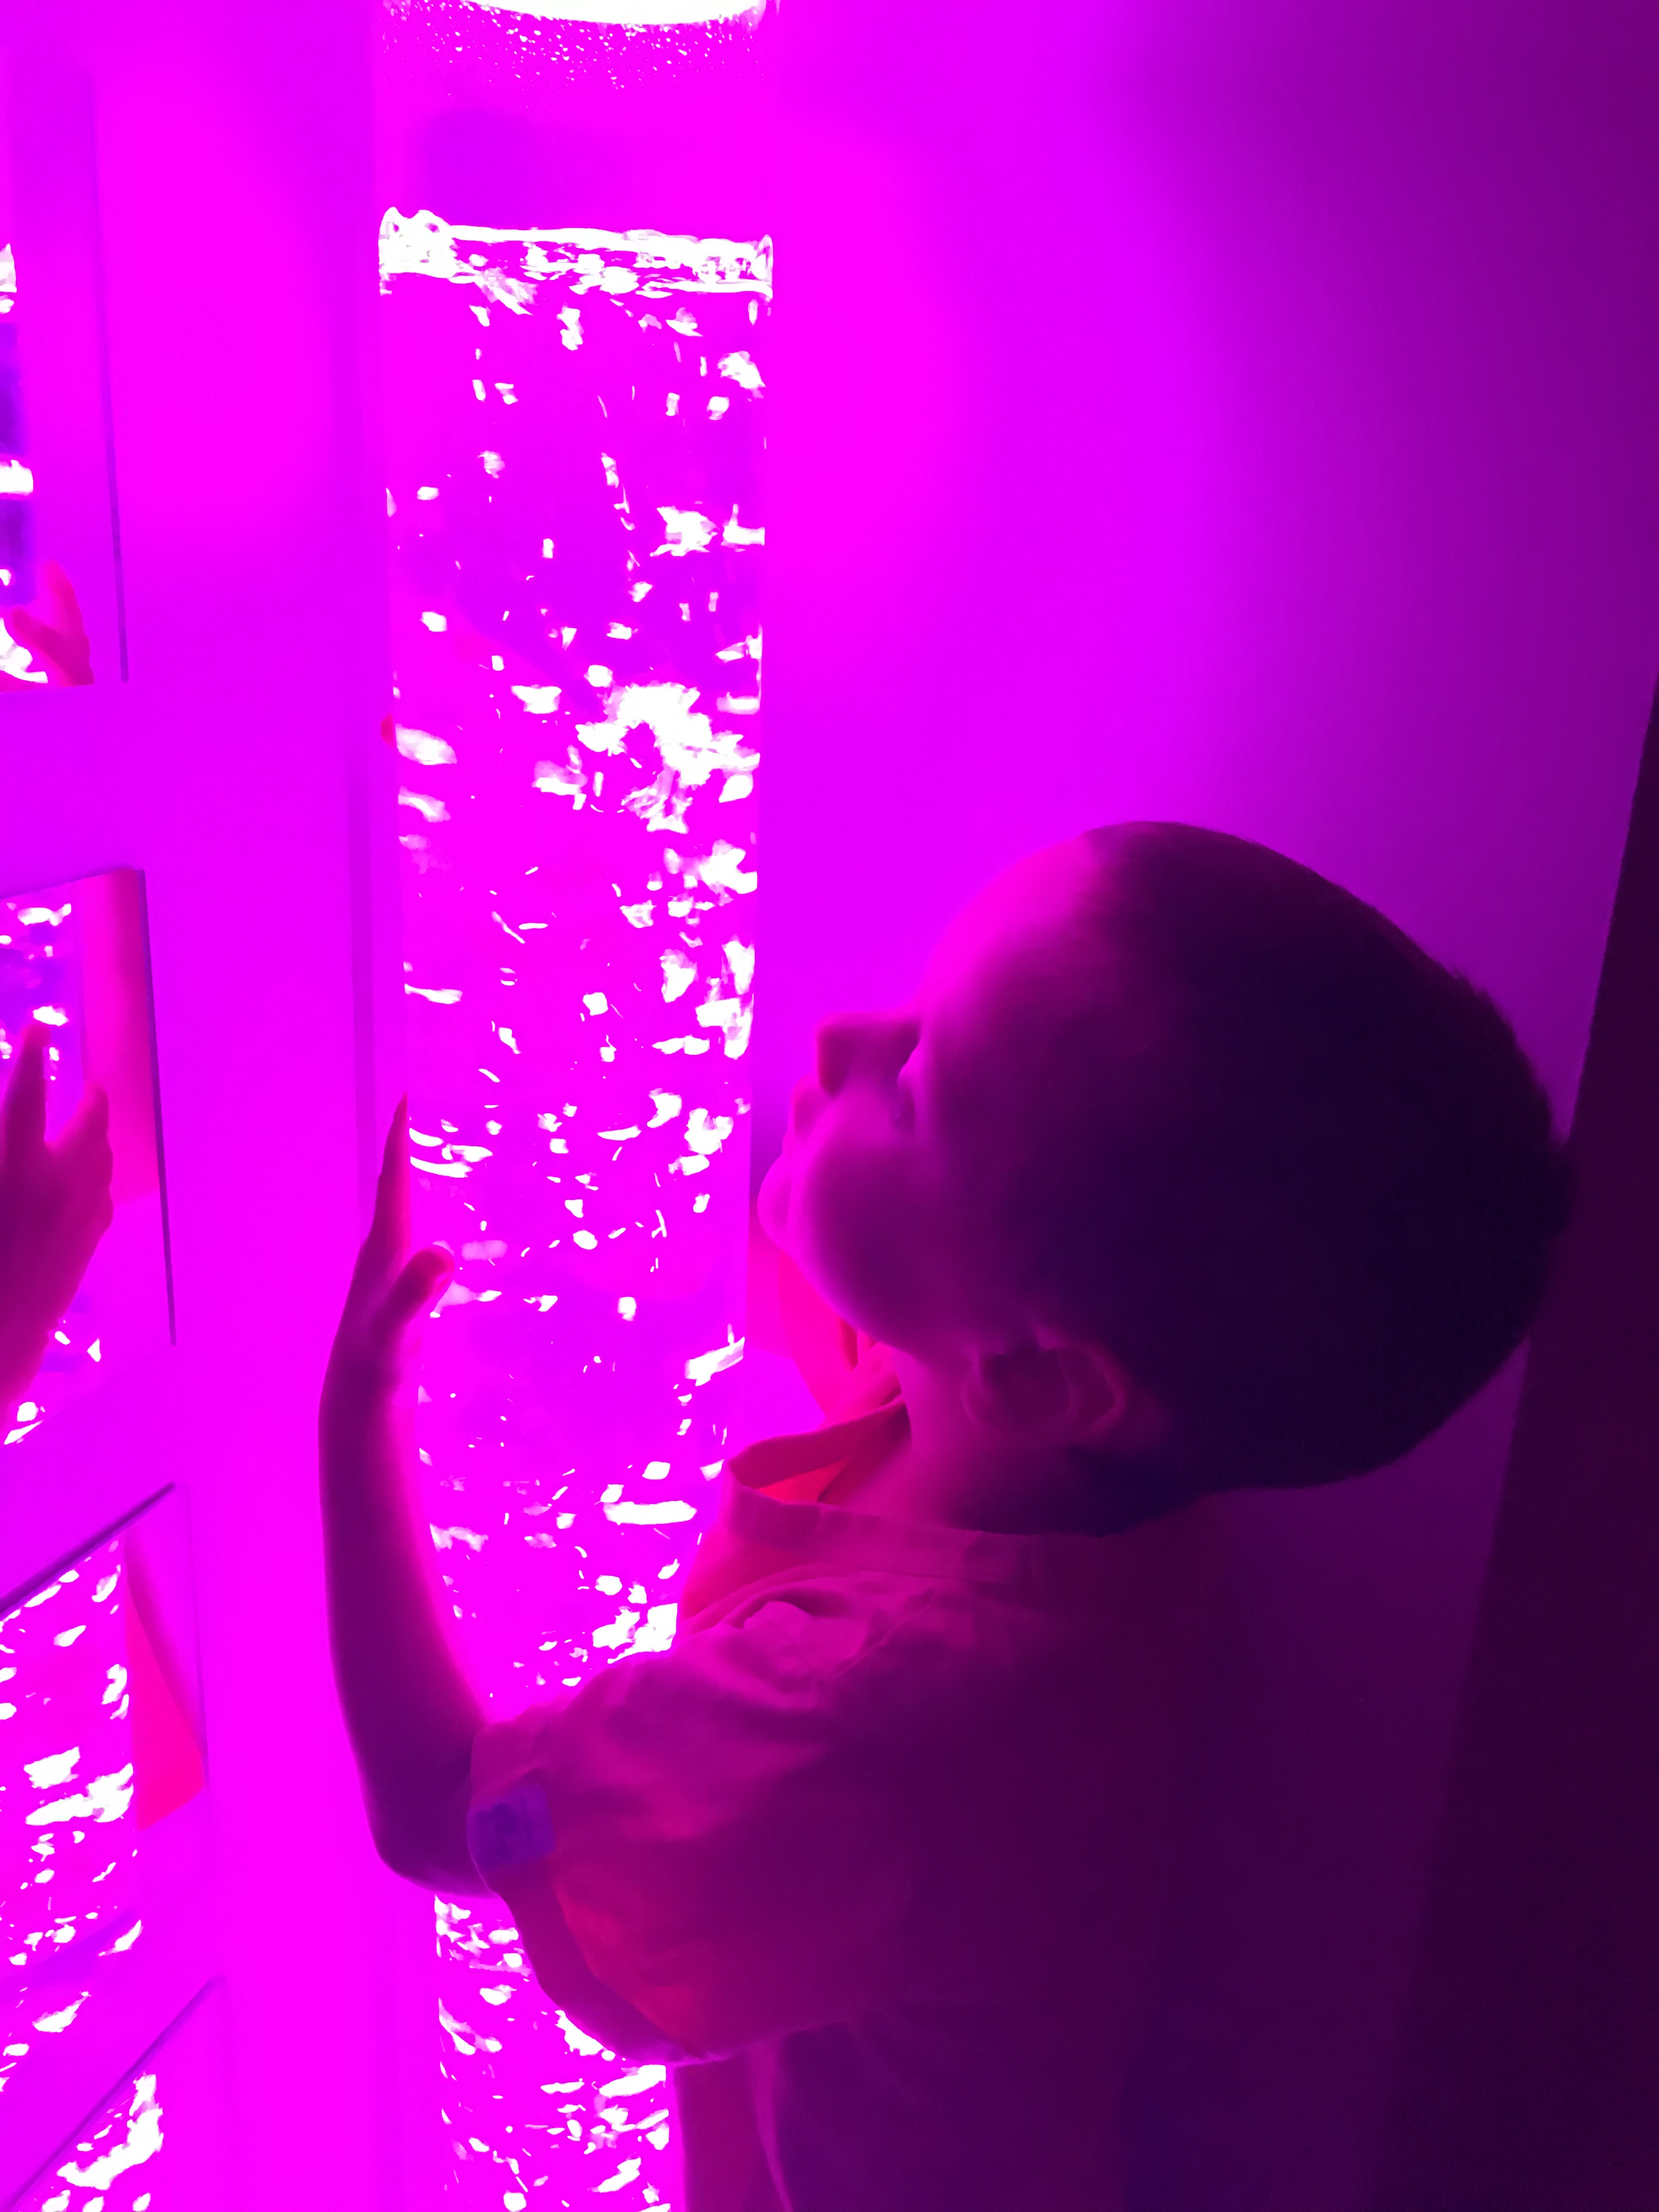
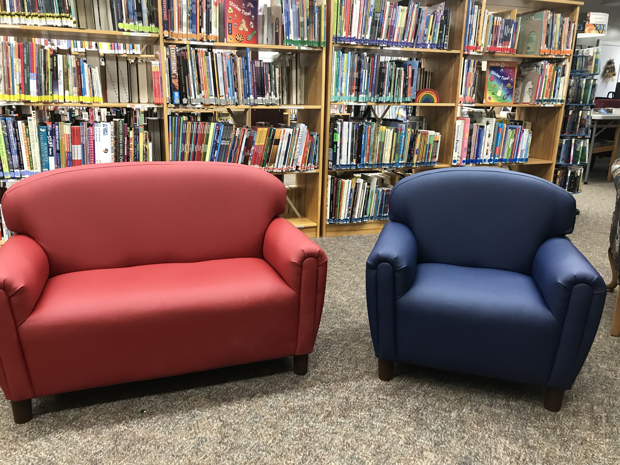







Logan’s Hideaway – Sensory Room
A Sensory Room is a therapeutic space that provides a safe environment for the person using it to explore and interact without risk.
The room has a range of stimuli to help individuals develop and engage their senses while also helping them to stay calm and focused.
These rooms include lights, colors, sounds, and sensory
soft play objects.

Individuals with Autism, Developmental Delays,
Communication Disorders, anxiety, Alzheimer’s, Dementia,
and other special needs could benefit from this therapeutic
environment.
Services with Fees
- Printing
- Photo Printer
- Photocopying
- Faxing Services
- Laminating
- Administrative Services

24/7 Inside & Outside of the Library
Connect to the “Public” wifi…no password
Sun Touch Plus Lamp

Sit in our cozy corner and get the benefits from our sun lamp!
There are 4 computers and 8 iPads for Public use within the library
E-books are available on ‘Libby’ for free with the use of your library card!
FREE

We also have…
Books
for Sale!!

Basement Available for Rent!
Contact the library during open hours to start booking your event today!

